**Electric Vehicle (EV) Market Segmentation Analysis**

**Prepared by: Team 2**

**1. Executive Summary**

The electric vehicle (EV) industry has undergone rapid growth in recent years due to increased environmental awareness, favourable government policies, and technological advancements. This report explores the various segments within the EV market, examining demographic, geographic, psychographic, and behavioural factors that influence consumer adoption and market expansion. The analysis draws on multiple data sources and analytical techniques, providing insights that are crucial for stakeholders such as EV manufacturers, policymakers, and charging infrastructure providers. By leveraging segmentation and predictive models, this report offers strategic recommendations to support the industry’s growth and sustainable future.

**2. Introduction**

Electric vehicles (EVs) represent a transformative shift in the automotive industry, providing a cleaner alternative to traditional internal combustion engine (ICE) vehicles. To optimize EV adoption, market segmentation helps stakeholders understand the diverse needs of consumer subgroups, allowing targeted marketing, product development, and infrastructure planning.

The objective of this report is to:

* Identify key segments in the EV market.
* Understand factors influencing EV adoption and market penetration.
* Provide actionable recommendations for infrastructure planning, marketing strategies, and policy initiatives.

**Data Sources:** This analysis leverages data from various GitHub repositories, including:

1. [**chaitu789/ev_market**](https://github.com/chaitu789/ev_market/tree/master)**:** Provides insights into EV market trends and consumer demographics.
2. [**leadoutrageous5/Market-Segmentation-EV**](https://github.com/leadoutrageous5/Market-Segmentation-EV)**:** Focuses on consumer segmentation models based on behavioral and psychographic factors.
3. [**Sujithreddy22k/FEYNN_LABS - EDA and Regression**](https://github.com/Sujithreddy22k/FEYNN_LABS/blob/main/ev_dataset_eda_and_regression.ipynb)**:** Uses exploratory data analysis and regression models to explore factors affecting EV adoption.
4. [**Suraj4n6/EV Market Analysis**](https://github.com/Suraj4n6/EV-MARKET-SEGMENT-/tree/main/EV-market-analysis-main)**:** Focuses on market analysis and charging station infrastructure.
5. [**Shivanigowda12/EV Charging Station Segmentation**](https://github.com/Shivanigowda12/EV-segment-charging-station-/tree/main/EV_Market_segmentstion-main)**:** Analyzes charging station placement and usage patterns.

**3. Methodology**

This report applies a combination of data analysis and machine learning techniques to derive meaningful insights:

* **Exploratory Data Analysis (EDA):** Used to understand data trends, relationships, and distribution, EDA involves data visualization methods like histograms, scatter plots, and heatmaps to reveal the underlying structure and patterns.
* **Clustering Algorithms (K-means):** The K-means algorithm helps divide the market into consumer subgroups or clusters based on factors such as demographics, usage patterns, and charging station proximity. Clustering is particularly useful for defining target groups and understanding differences within the market.
* **Regression Analysis:** Regression models (linear and multiple) identify key predictors for EV adoption. These models quantify the influence of factors like income, charging station density, and government subsidies on the likelihood of adoption.

**4. Market Segmentation Analysis**

Market segmentation in the EV industry is multifaceted, encompassing demographic, geographic, psychographic, and behavioural factors:

**4.1 Demographic Segmentation**

* **Age and Income:** Younger consumers (ages 25–40) exhibit a higher tendency to adopt EVs, often driven by sustainability concerns and lifestyle compatibility. Income also plays a critical role, as higher-income groups are more likely to afford EVs, especially luxury models. This demographic segment often has a higher willingness to pay for eco-friendly options.
* **Occupation and Education Level:** Professionals and individuals with higher educational backgrounds demonstrate greater interest in EVs, as they are generally more aware of environmental issues and responsive to technological advancements.

**Insights:** Targeted marketing campaigns could appeal to these groups by emphasizing eco-friendliness, cost savings on fuel, and alignment with modern lifestyles.

**4.2 Geographic Segmentation**

Geographic analysis reveals that EV adoption is higher in urban areas, where the density of charging stations and overall infrastructure is more developed. Conversely, rural and suburban areas face limitations due to sparse charging infrastructure.

* **Urban Centers:** Fast-charging stations are concentrated in city centres, supporting the needs of high-density populations and frequent commuters. EV ownership is more feasible in these areas due to accessible charging points.
* **Suburban and Rural Areas:** EV adoption in these areas is relatively lower, attributed to the limited availability of charging infrastructure and longer travel distances. However, suburban regions with strong commuter routes can benefit from strategically placed fast-charging stations.

**Insights:** Investments in suburban and rural charging infrastructure could accelerate EV adoption in these regions, especially if combined with incentives for home charging setups.

**4.3 Psychographic Segmentation**

Psychographic segmentation categorizes consumers based on attitudes, values, and motivations:

* **Environmental Advocates:** These consumers prioritize sustainability and are early adopters, often driven by concerns about emissions and climate change. They value EVs as part of an eco-conscious lifestyle.
* **Cost-Sensitive Consumers:** Motivated by long-term fuel savings and lower maintenance costs, these consumers respond well to government incentives that reduce the initial cost burden.
* **Technology Enthusiasts:** Typically well-versed in technology, this group embraces EVs as innovative and modern. They are likely to appreciate advanced features and the seamless integration of digital services, such as remote vehicle monitoring and app-based charging.

**Insights:** Marketing strategies can tailor messaging for each psychographic segment, such as emphasizing cost savings for budget-conscious consumers or innovation for tech enthusiasts.

**4.4 Behavioural Segmentation**

Behavioural segmentation focuses on usage patterns, charging preferences, and purchasing frequency:

* **Usage Patterns:** Frequent drivers and long-distance commuters prioritize fast-charging options, while occasional users may rely on home or workplace charging.
* **Charging Preferences:** Analysis from the **Shivanigowda12** repository reveals a preference for fast-charging stations in high-density areas, as these meet the immediate needs of time-sensitive drivers.
* **Purchase Behaviour:** Consumers who prioritize convenience and sustainability are more likely to adopt EVs sooner, while those needing to travel longer distances might wait until infrastructure expands.

**Insights:** Placing fast-charging stations in areas with high commuter traffic and optimizing their usage based on behavioural patterns can support a seamless transition to EVs for these users.

**5. Charging Infrastructure Analysis**

Charging infrastructure plays a crucial role in EV adoption. A detailed analysis from the **Suraj4n6** and **Shivanigowda12** repositories highlights the importance of both station density and type.

* **Urban Charging Needs:** High-density urban areas require fast-charging stations that can accommodate multiple vehicles at once. Locations near commercial zones, residential complexes, and shopping malls are ideal for maximizing usage.
* **Suburban and Rural Charging Needs:** Standard charging stations are suitable for suburban and rural areas with lower traffic volumes. Fast-charging hubs located near major transit routes can serve long-distance travelers effectively.

**Optimal Placement Recommendations:**

* **Urban Centers:** Prioritize high-traffic locations with fast-charging capabilities.
* **Suburban Areas:** Use a mix of standard and fast chargers, especially along commuter routes and near park-and-ride stations.

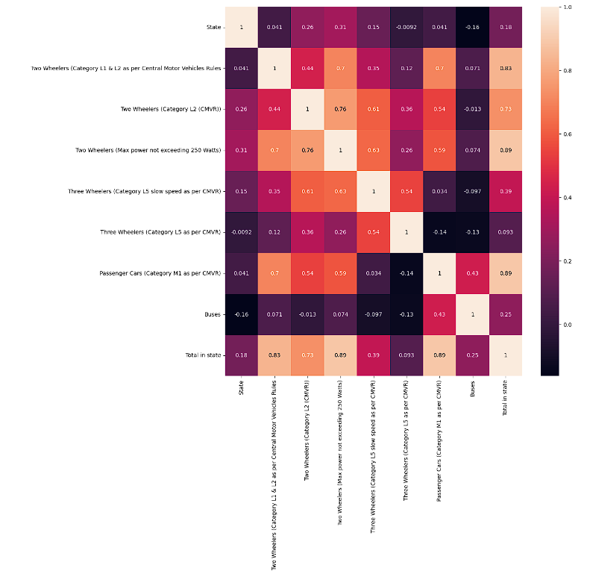

**Insights:** Infrastructure investments should prioritize metropolitan and high-traffic suburban areas, with a balanced approach for rural locations.

**6. Predictive Analysis Using Regression Models**

The **chaitu789/ev_market** and **Sujithreddy22k/FEYNN_LABS** repositories provide regression analyses that identify factors impacting EV adoption, such as:

* **Ownership Costs:** Lower ownership costs, including purchase incentives and reduced maintenance costs, correlate positively with adoption rates.
* **Charging Infrastructure Density:** Higher charging station density boosts adoption, especially in metropolitan regions where accessible infrastructure is crucial.
* **Government Incentives:** Tax rebates and subsidies directly influence adoption by making EVs more affordable.

**Insight:** Policies that reduce EV ownership costs and expand charging infrastructure are likely to significantly boost adoption.

**7. Conclusion**

In summary, the EV market segmentation analysis provides valuable insights into key consumer segments and the importance of a robust charging infrastructure. Findings indicate that:

* **Primary Target Segments:** Urban, young, and environmentally conscious consumers with mid-to-high incomes.
* **Infrastructure Focus:** Expansion of charging facilities in suburban and rural areas can enhance adoption rates.
* **Marketing Focus:** Emphasizing cost and environmental benefits appeals to the sustainability-minded and cost-sensitive segments.
* **Production:** The most feasible and profitable Vehicle in this market are the 2 wheelers and 3 wheelers as they are cost efficient and comes in the regular budget of the population.

**8. Recommendations**

1. **Infrastructure Development:** Increase investment in fast-charging stations in urban areas and strategically place standard chargers along major transit routes in suburban areas.
2. **Incentive Programs:** Maintain or expand government subsidies to lower initial costs, which can make EVs more accessible to a broader demographic.
3. **Targeted Marketing:** Develop campaigns that highlight both the environmental benefits and cost savings to appeal to sustainability-oriented and budget-conscious consumers.
4. **Further Research:** Continued analysis of behavioural data on charging preferences will allow for more precise segmentation and infrastructure planning.

**9. Appendices**

* **Appendix A:** Visualizations for demographic and psychographic clusters
* **Appendix B:** Regression model data and predictive output tables
* **Appendix C:** Sample code snippets and data source links from GitHub repositories